Pre-Use Inspection

Vehicle Make/Model/Year____________________________________________

Date of Pre-Trip Inspection___________________________________________

Person Performing Inspection_________________________________________

Proof of Insurance/registration/inspection and valid driver’s license submitted? __

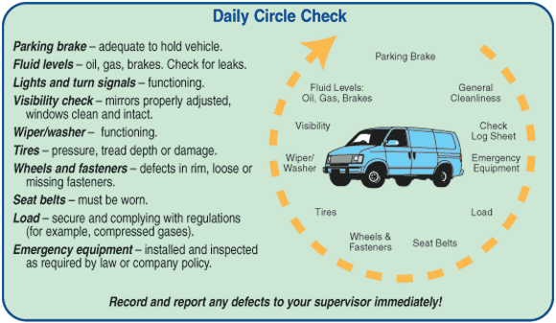

Item | Safe | Needs Attention
Before starting engine check:  - Fluid Levels  - Mirrors/windows  - Wipers  - Parking brake  - Foot Brake  - Tires  - Seatbelt damage  - Steering (any play)  - Lights  - Turn Signals  - Horn  - Emergency Equip | □  □  □  □  □  □  □  □  □  □  □  □ | □  □  □  □  □  □  □  □  □  □  □  □

