RESPIRATORY PROTECTION PROGRAM

INTRODUCTION
is committed to the protection of our employees from occupational hazards, including the potential health risks associated with exposure to airborne contaminants such as dusts, mists, fumes, and gases, or oxygen-deficient atmospheres. goal is the control of airborne contaminants by accepted engineering and safe work practices. When effective engineering controls are not practicable, or while they are being instituted, appropriate respiratory protection must be used. Personal Protective Equipment (PPE), including respirator protection, is normally the last resort in minimizing the hazards of airborne contaminants. Inhalation is generally viewed as the most significant route of entry for toxic materials in most workplaces. The specific airborne hazards that employees are exposed to will vary and depend upon their job task and environment at the time.

RESPONSIBILITY
Supervisors and their designates shall monitor respirator use in relation to workplace conditions to ensure that respiratory protection program requirements are being met and shall ensure that:
- User screening, training, fit testing and where required medical assessments are completed prior to assigning a user any task that requires the use of a respirator.
- Users demonstrate competency in the use of the respirator.
- Users follow written instructions and manufacturer recommendations to ensure respirators are
  - Cleaned, inspected, maintained, repaired, and stored and
  - Sanitized and decontaminated when required.
- The respirator is used in accordance with the instructions, the training received, and the safe operating procedures established for the workplace.
- In the case of a tight-fitting respirator, respirator users maintain their required interference-free respirator seal and do not have any object or materials on their person that would interfere with the seal or operation of the respirator.
- Details of the type of respirator selected and the anticipated working conditions are provided to the health care professional conducting the medical assessment of a respirator user, where required.
- The program administrator is notified of respirator users’ concerns, changes in processes, equipment or operating procedures that have an impact on environmental conditions and respiratory protection requirements; and
- The program administrator is notified of investigation reports that indicate that the use of a respirator could have prevented or contributed to an incident or injury.

Employee Responsibilities
Each employee must wear his or her respirator when and where required, under the conditions
specified in this program. They are also obligated to use the equipment according to the training
procedures for each model.
Employees are also responsible for the following:
- Being familiar with this program.
- Report any conditions that may impair their ability to safely use a respirator.
- Maintain their respirator seal interference-free; refrain from having anything on their person that would interfere wit the seal or operation of the respirator.
- Check that the respirator is clean and in good operating condition prior to each use and at intervals that will ensure that it continues to operate effectively.
- Perform user seal checks (Appendix F) after each donning of a tight-fitting respirator.
- Remove from service any respirator that they determine to be defective and report it to their supervisor or other responsible person.
- Report to their supervisor or other responsible person when there is any condition or change that could impact their ability to safely use the selected respirator.

HAZARD ASSESSMENT

To determine the presence of a respiratory hazard and assist in selection of appropriate respirator, a hazard assessment will be conducted when conditions or tasks change. A respiratory hazard assessment may include the following (Refer to Appendix E):
- Identify what contaminants are present in the workplace
- Identify the physical states of all airborne contaminants
- Measure or estimate the concentration of the contaminants
- Determine if the atmosphere is potentially oxygen deficient
- Identify an appropriate occupational exposure limit for each airborne contaminant
- Determine if an IDLH atmosphere is present (refer to NIOSH 2005-149 for IDLH values for specific substances)
- Determine if there is an applicable health regulation or a substance-specific standard for the contaminants
- Determine for particulate hazards if there is oil present
- Determine if the contaminant can be absorbed through, or is irritating to, the skin or eyes.

**An IDLH (Immediate Danger to Life and Health) will be assumed when one or more of the following circumstances exist:
- A known contaminant at or greater than an IDLH concentration
- A known contaminant at an unknown but potentially toxic concentration
- An unknown contaminant
- An oxygen deficiency exists
- A confined space
- Contaminants at or above the Lower Explosive Limit (LEL)
- Firefighting

SELECTION OF RESPIRATORS
Respirator classifications and descriptions can be found on Appendix B.
This Respiratory Program does not apply to respirator selection for protection against bioaerosols. Refer to CSA Z94.4 for further information.

- Respirators shall be selected based on the following criteria:
- Health of the worker and ability to wear a respirator (Appendix A)
- Review of the hazard assessment
- Existing legislation and standards
- Work requirements and conditions
- Duration of exposure
- Characteristics and limitations of respirators
- Respirator assigned protection factors

- Only accepted respirators shall be selected and used.
- Respirators shall be selected with supervisors and employee input.
- Refer to the Respirator Selection Chart (Appendix C).
- Workers shall only use respirators for which they have been fit tested.
- Change out schedules for the replacement of their cartridges shall be established.
- SCBA’s of the demand type shall not be used in IDLH situations.
- Respirators approved for escape shall not be used for non-emergency applications.

FIT TESTING OF RESPIRATORS

- All employees who may use a respirator with a tight-fitting face piece in the course of their job are required to be fit tested by a qualified person.
- A fit test shall be performed:
- Prior to the initial use of a tight-fitting respirator
- Every two years
- Whenever there is a change in respirator face piece (make, model or size)
- Whenever the employee reports or changes in the employee’s physical condition are observed that could affect respirator fit. Such conditions may include, but not be limited to facial scarring, dental changes, cosmetic surgery, obvious changes in body weight, dermatological condition, etc.…
- The employee shall be fit tested with the same respirator make, model, style, and size of respirator they will be using at the job.
- All PPE required for the job will be worn during fit testing to ensure compatibility and to check for interference with the facial seal.
- Employees must be clean shaven where the face piece seals to the skin when fit testing is performed.

TRAINING

All employees whose work requires the use of a respirator will receive appropriate training and education prior to their initial use of the respirator and refresher training annually. Training records shall be maintained and updated as required.
Training shall include:
- Discussion including nature, extent, and effects of respiratory hazards the worker may be exposed to.
- Rationale for respirators selected and where to find more information.
- Emergency procedures.
- Care and practical use of respirators consisting of instruction, demonstration, participant practice and demonstration of competency in procedures and practices relating to
  - Donning and doffing
  - User seal checks,
  - Care
  - Cleaning
  - Inspection
  - End-of-service recognition
  - Change-out of filter elements
  - Replacement of air cylinders
  - Identification of problems
  - Use under failure or emergency modes
  - Storage
  - Removal from service
  - Basic maintenance and
  - Familiarity with and adherence to the manufacturer’s instructions
  - Limitations

**Training in the use of self-contained breathing apparatus (SCBA), if required, will be provided by a qualified external trainer.

USE OF RESPIRATORS

- Employees must complete the form - Initial Assessment for Respirator Use (Appendix A), have a fit test and meet training requirements prior to using a respirator.
- Facial hair, temples on eyeglasses, straps, jewellery, or any other materials including PPE shall not interfere with the seal of the face piece (on tight-fitting respirators) to the employee.
- The seal shall be checked by the employee immediately after putting on the respirator. If a tight seal cannot be maintained on a tight-fitting respirator it shall not be worn.
- The seal of the face piece shall not be broken for the employee to communicate.
- Employees shall never remove their face piece at anytime while working in an IDLH atmosphere.
- Employees will be permitted to leave the hazardous area for any respirator related reason including but not limited to:
- The respirator doesn’t provide adequate protection.
- The respirator malfunctions.
- The user detects air leakage around the face seal.
- The user detects an odour or tastes a chemical.
- The user has increased breathing resistance.
- The user experiences any illness or discomforts such as dizziness, nausea, weakness, breathing difficulties, sneezing, fever, chills, confusion, etc.…
- Components (including air tanks) or purifying devices need change-out.
- Respirator cartridges and accessories shall be from the same manufacturer as the respirator (e.g., NORTH cartridges for a NORTH respirator).
- Where respirators are used for confined space entry, HAZMAT response; appropriate legislation shall be consulted.

CARTRIDGE AND CANISTER CHANGE OUT SCHEDULES

Organic vapor/acid gas cartridges/canisters with a P-100 prefilter must be changed after 8 hours of use or at the end of the shift, which ever is shorter.
Employees wearing APR with P-100 filters for protection against wood dust and other particulates must change their cartridges when:
- There is increased resistance breathing through the filter.
- Filter becomes damaged or unhygienic.

EQUIPMENT MALFUNCTION

Air-Purifying Respirators (APR)
If an APR or any of its component’s malfunctions (breakthrough, facepiece leakage, or faulty
valve), the wearer must leave the respirator use area immediately and notify the supervisor about
the malfunction. The supervisor is then responsible for ensuring that the employee receives the
necessary repair parts or a new functional respirator.

Supplied-Air Respirator (SAR)
Usually, employees using SAR work in pairs. If one experiences an SAR malfunction, then
he/she notifies the partner of the problem by using hand signals. The partner then escorts the
affected employee outside the respirator use area.

CLEANING, INSPECTION, MAINTENANCE, AND STORAGE OF RESPIRATORS

- Each respirator shall be cleaned and sanitized according to the manufacturer’s instructions and/or according to procedures found in Appendix D.
- If a respirator is issued to an individual employee, it will be cleaned and disinfected as is necessary to maintain good hygiene.
- If there are multiple users of a single respirator, the respirator must be cleaned and disinfected before each use.
- Respirators designated for emergency use only must be cleaned after each use.
- Employees will inspect their respirator before and after each use according to inspection procedures found in Appendix D.
- SCBA’s will be inspected and serviced by a qualified person and on a schedule that ensures readiness for anticipated emergency use.
- Any respirators found in need of repairs / replacement will be tagged, removed from service, and reported to a supervisor.
- Records will be kept of all maintenance performed on the respirators.
- Respirators will be stored in a clean and sanitary location protected from dust, ozone, sunlight, heat, extreme cold, excessive moisture, vermin, damaging chemicals, oils, greases, or any other potential hazard that may have a detrimental effect on the respirator.
- Used cartridges/filters shall be stored in a manner to prevent contamination of the respirator face piece.

HEALTH SURVEILLANCE

- Prior to fit testing and/or respirator use, the employee must be assessed for conditions that may preclude them from wearing a respirator. This is achieved through their completion of the “Initial Assessment for Respirator Use” form. A Supervisor trained in the use of Respirators in cooperation with the OH&S representative / committee will review the form and evaluate the employee on their ability to use the selected respirator or make recommendation for the employee to have a medical evaluation completed by a practicing physician.

- Employees who are not approved in the use of respirators shall not work in an area where the use of a respirator is required.

PROGRAM REVIEW

The Respiratory Protection Program shall be reviewed regularly and will include:

- A review of program elements to ensure they meet regulatory requirements
- A review of documented procedures
- A review of roles and responsibilities
- A review of records to ensure documented procedures are being followed
- Confirmation that workplace practices comply with program requirements
- Documentation of performance problems and resolution of problems or corrective action plans.
- Verification of employee acceptance
- Proper selection and use of respirators
- Effective training of supervisors and employees involved in the use and care of respirators
- Proper inspection of respirators
- Proper storage and maintenance procedures of respirators

RECORDKEEPING

Records shall be kept for the duration of employment or for a minimum of 10 years. Records should include:
- Workplace hazard assessments
- Selection of respirator
- Training
- Fit tests
- Cleaning, maintenance, and storage of respirators
- Health surveillance
- Program evaluation

APPENDIX A – Respirator User Screening Form
(Not Included)

APPENDIX B –Classification and Description of Respirators

- Air Purifying Respirators, Non-Powered (APR) and Powered (PAPR)
Types:
- Gas and vapour- removing.
- Particulate-removing.
- Gas-, vapour-, and particulate-removing; and
- Multi-functional (a configuration incorporating both APR and PAPR).

These respirators may be used to protect against airborne contaminants by filtering out particulates such as dusts, metal fumes, mists, etc.… Another type of APR purifies the air by adsorbing gases or vapours on a sorbent in a cartridge. These are tight-fitting respirators and are available in several forms (quarter-mask, half-face mask and full face-piece).
Air Purifying respirators must never be used in oxygen-deficient atmospheres that are immediately dangerous to life and health (IDLH).

- Atmosphere-Supplying Respirators
Types:
- SCBA (pressure demand, open or closed-circuit).
- Airline (SABA) (pressure demand or continuous flow); and
- Multi-functional (a configuration incorporating both SCBA and airline)

These respirators supply clean air from a compressed air tank or an airline and not from the work environment itself. This air is required to meet certain criteria based on standards, e.g., CSA Standard Z180.1-00: Compressed Breathing Air Systems.

- Combination Respirator (a configuration incorporating both atmosphere-supplying and air-purifying).
And
Escape-only respirators (atmosphere-supplying or air-purifying).

APPENDIX C - Respirator Selection
NIOSH 42CFR 84 has nine classes of filters. These incorporate three levels of filter efficiency (95%, 99% and 99.97%) each with three categories of resistance (N, R and P) to filter degradation. Filter degradation is defined as a lowering of filtration efficiency (ability to remove particles) as a result of workplace exposure.
“N” respirators are for general purpose use but are Not Oil Resistant.
“R” respirators are oil resistant and may be used in such applications for one shift only.
“P” respirators are oil proof and may be used for more than one shift.
The selection of filter efficiency (i.e., 95, 99, or 99.97%) depends on how much filter leakage can be accepted.

Figure 1 – Respirator Selection Flow chart; must be used in conjunction with CSA Standard Z94.4-18 to determine appropriate respirator.

APPENDIX C - Respirator Selection Continued…
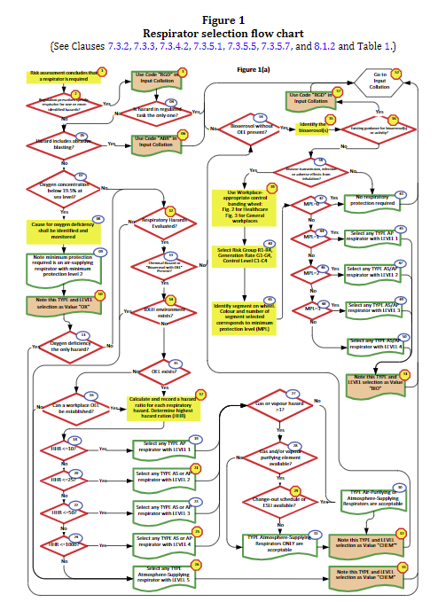
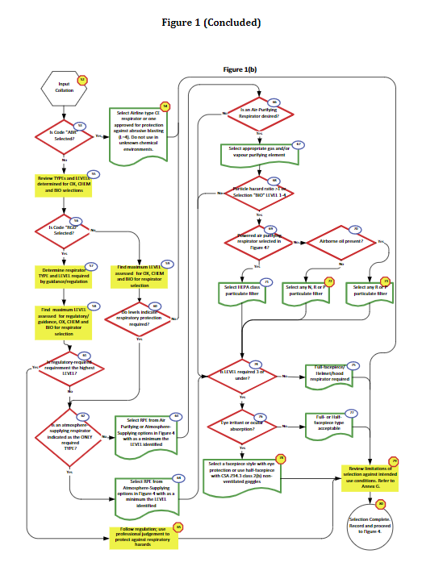

APPENDIX D – Respirator Maintenance
Maintenance includes cleaning / disinfecting, inspection, storage and repair
- Cleaning & Disinfecting
- Remove filters/cartridges/canisters. Disassemble facepiece. Check for parts in need of repair or replacement.
- Wash respirator parts in warm water with a mild soap and disinfectant or a cleaner recommended by the manufacturer.
- Rinse all parts thoroughly in clean, warm water.
- All parts should be allowed to air dry or dry with a clean, lint free cloth prior to being reassembled.
**If the respirator is used by the same person, then disinfecting is not required.
- Inspecting
(For inspecting SCBA, follow CSA Z94.4 and manufacturer instructions)

- Check the condition of all respirator parts:
- Look for cracks, cuts, tears, holes, and distortion.
- Check elasticity of straps, secure attachment, and broken buckles or tears.
- Check valves for damage.
- Check for cracks and pliability to all rubber on the respirator.
- Check for any other cracks, tears, or torn seams if applicable on the respirator assembly.
- Ensure cartridges or filters fit securely with the respirator facepiece.
- Check the end of service life indicator or the expiration date if applicable.
- Ensure all regulators, alarms or other warning systems are functioning properly.
- Check all hoses for damage or worn material.

APPENDIX E – Respiratory Hazard Assessment
Refer to Safety Form – Respiratory Hazard Assessment (spreadsheet)

APPENDIX F – Seal Check Procedures (from Respirators Rule)

