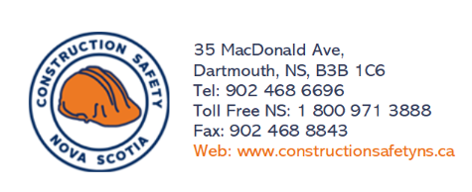

General Safe Work Practice for Team Lifting

DO:
- Organize the lift. One person should take the lead for giving orders to lift, turn, and set down. But everyone involved must understand what needs to be done before getting started.

- Lift and lower in the same manner. Each worker should follow the same safe lifting technique. Squat down close to the load, maintain a firm grip, keep back straight and lift with their legs.

- Move slowly. The load should be carried without sudden stops and all workers must watch where they are going.

- Keep the load level and the weight evenly distributed. Workers should be especially careful when traversing slopes or egress

- Carry long loads on the same shoulder. Each worker involved in the lift/move should share carry long items like pipes or boards on the same shoulder.

- Never walk backwards. Make sure a path is clear and an extra team member should act as a guide during the move.

Do Not:

- Twist bodies when lifting or carrying
- Lift with your back
- Change grip while holding or moving objects
- Step over objects or travel through/over hazardous obstacles

