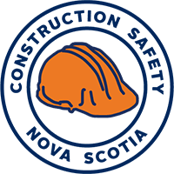 | 35 MacDonald Ave,  Dartmouth, NS, B3B 1C6  Tel: 902 468 6696  Toll Free NS: 1 800 971 3888  Web: www.constructionsafetyns.ca
SAFE WORK PRACTICE
Name of Job:  Welder - General | Development Date: | Developed By: | Approved By: | Review Date:
Possible Hazards Present
Working at heights | Working in confined spaces | Risk of eye injury | Slips, trips and falls
Risk of injury from falling objects | Burns from hot surfaces, flames, sparks, etc., | Exposure to lead and other toxic heavy metals | Proximity to flammable or combustible materials
Personal Protective Equipment (PPE) and Devices Recommended
Head protection | Eye Protection | Foot protection | Fall Arrest Equipment
Respirator Equipment | Skin Protection | Hearing Protection

What are some good general safe work practices?
- DO general information/tips about welding
- DO follow proper selection, use, maintenance and storage of PPE
- DO follow confined space entry procedures
- DO follow fall protection procedures
- DO follow lock-out / tag-out procedures
- DO Know how to work safely with flammable and combustible liquids
- DO know how to work safety with compressed gases
- DO know how to work safely with power tools, and
- DO follow safe work procedures on ladders, and platforms / scaffolds
- DO follow manual material handling (lifting) techniques

