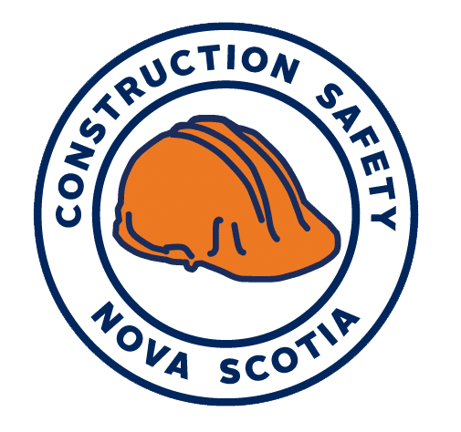
Annual General Meeting 2019
Virtual
MEETING MINUTES
June 17, 2020
Board Present/ Joining Virtually:
Dan O’Conner, Director
Dan Monk, Director
Heather Cruickshanks, Director
Don Maillet, Treasurer
Andrew Holley, Chair
Milton Howley, Director
Kent Nickerson, Past Chair
Melvin Gillis, Director
Duncan Williams, Director
Staff Attending/Virtually:
Jason Nicholson
Damon Alcock
Katie Feltmate
Jonathan White
Craig Walker
Ryan Quinn
Phil Brownell
Laura Langille
Stacia Baldwin
Jennifer Roberts
Kyla Porter
Tara Armstrong
Cynthia Colpitts
Joyce van der Kooi
Jo-Ann MacDonald
Cindy Boyce
Laura Langille
Santanna Coleman
Mike Adair
Jess Meldrum
Amie Walton
Lori Ross
Melissa Deir
Quinton Bragg
Absent: Brad Smith, Director

Welcome and Introduction 10:00 a.m.
MJ MacDonald delivered the opening remarks of the 26th Annual AGM and Awards Ceremony, highlighting the agenda and the Covid-19 protocols in place for the virtual meeting.

Meeting Call to Order 10:10 a.m.
Board Chair, Mr. Andrew Holley welcomed everyone again and provided introductory remarks. Mr. Holley asked everyone to review the agenda and the 2019 meeting minutes and asked if there are any amendments or if both may be approved.
Motion to Approve the Agenda: Mr. Kent Nickerson motioned to approve the agenda, Mr. Don Maillet seconded, unanimous approval, motion carried.
Motion to Approve the May 15, 2019 Minutes: Mr. Don Maillet motioned to approve the minutes, Mr. Kent Nickerson seconded, unanimous approval motion carried.
Mr. Andrew Holley asked if anyone is contrary minded. There are no issues presented.
Chair’s Report 10:15 a.m.
Mr. Andrew Holley presented his report, reflecting on the past year and acknowledging the work of the board and staff of the Association.

Chair Awards of Excellence 10:20 a.m.
Mr. Damon Alcock presented the Chair’s Awards of Excellence to the seven safest companies with the lowest claim cost.
- EastPoint Engineering Limited: (Payroll: $1,000,000+)
They have been COR certified since 2017.
- The Shaw Group Limited: ($750-999K)
They have been COR certified since 1997.
- John Morrison Contracting Limited: (500-750K)
They have been COR certified since 2003.
- G Landry Vacuum Service Ltd: (250-500k)
They have been COR certified since 1998.
- Forges Drywall Limited: (100-250k)
Forges Drywall Limited has been COR certified since 2014.
- Kenneth Julian: (50-100k)
COR Certified since 2002.
- Aylesford Electric Limited (Less than 50k)
COR Certified since 2011.
Nomination Report 10:25 a.m.
Mr. Kent Nickerson presented the nomination report for the directors of the board. There were no nominations from the floor.
This years’ founding member board nominees include:
- Representing the Canadian Home Builders Association Nova Scotia as Board Chair, Andrew Holley.
- Representing the Canadian Home Builders Association Nova Scotia as Director, Dan Monk.
- Representing the Atlantic Concrete Association and serving as Past Chair, Kent Nickerson.
- Representing the Department of Transportation and Infrastructure Renewal as Treasurer, Don Maillet.
- Representing the Mainland Nova Scotia Building and Construction Trades Council, as Director Brad Smith
- Representing the Construction Association of Nova Scotia as Director, Heather Cruickshanks.
- Representing the Construction Association of Nova Scotia as Director, Duncan Williams.
- Representing the Nova Scotia Road Builders Association as Director, Dan O’Connor.
- Representing the Cape Breton Island Building and Construction Trades Council as a Director, Melvin Gillis.
- Representing Nova Scotia Power, as Director Milton Howley.
Motion to Approve the Nomination Report: Mr. Don Maillet motioned to approve the report, Mr. Andrew Holley seconded, unanimous approval, motion carried.
Treasurer’s Report 10:30 a.m.
Mr. Don Maillet presented his Treasure’s report reflecting on the financial position of the organization. Mr. Jason Nicholson then presented the highlights of the financial statements for the 2019 year and asked if there were any questions.
Motion to Approve the 2019 Financial Statements: Mr. Kent Nickerson motioned to approve the statements, Mr. Andrew Holley seconded, unanimous approval, motion carried.
Motion to Appoint Baker Tilly as 2020 Auditors: Mr. Andrew Holley motioned to approve the appointment, Mr. Kent Nickerson seconded, unanimous approval, motion carried.

Awards Presentations 10:35 a.m.
Mr. Damon Alcock presented the following awards:
- Women and Safety Leadership- Lissa Gaudet, McNally Construction
- Safety Champion Award – Clearview Window Cleaning
- Safety Innovation Award- Weldon Contracting
- Best Practice Award- Quality Concrete

Keynote Speakers 10:47 a.m.
Mr. Damon Alcock introduced the keynote speakers, Andy Stevens and Antony Murray. The presentation centered around mental health in construction and ran for around 30 minutes followed by a question period. Several questions were asked around what employers can do to do support the mental health of their staff.

CEO’s Report 11:40 a.m.
MJ MacDonald presented her first report as CEO of Construction Safety Nova Scotia.
Motion to Accept CEO Report: Mr. Andrew Holley motioned to approve the report, Mr. Kent Nickerson seconded, unanimous approval, motion carried.

Member’s Forum 11:55 a.m.
MJ MacDonald asked if there were any further questions from the membership. There were no questions.

Motion to Adjourn 12:00 p.m.
Mr. Kent Nickerson was invited up to the podium with a motion to adjourn.
Motion to Adjourn: Mr. Andrew Holley motioned to approve the report, Mr. Don Maillet seconded, unanimous approval, motion carried.

Member Quorum:

- Hilltop Electrical & Plumbing
- Bourque Security Services NS
- J. Elliot Construction
- Doug Burgess Electrical
- Webster Bros Paving
- Edmonds Landscape & Construction Services
- Vinland Contracting Inc
- Bird Construction
- Sawlor Built Homes
- HRS Industrial
- Marid
- Roscoe Construction
- Carpenter Millwright College
- Deveau Consulting Limited
- Anything N Everything?
- McLeans Flooring
- Nova Tile
- Trunk 7 Contracting Ltd.
- Lancor Concrete Contractor
- ElisDon
- Paint Emporium Atlantic
- OSCO Construction
- D.H Weatherdon
- Alex Fitzgerald Construction
- Quality Concrete
- McNally Construction
- Weldon Contracting
- Clearview Industrial Services Incorporated
- Atlantic Concrete Association
- Canadian Home Builders Association of Nova Scotia
- Department of Transportation and Infrastructure Renewal
- Mainland Nova Scotia Building and Construction Trades Council
- Construction Association of Nova Scotia
- Nova Scotia Road Builders Association
- Nova Scotia Power
- Cape Breton Island Building and Construction Trades Council

