THE SAFETY PLAN

HEALTH AND SAFETY PLAN

For a project manager, a “Safety Plan” provides a blueprint or checklist to ensure that appropriate controls exist to ensure against loss and also ensure compliance with OHS legislation. The role of a project manager is to communicate, co-ordinate, and control information and activities that may impact the project.

Contents may vary from project to project; however the following elements should be contained in all safety plans:

Policies - All policies relevant to OHS and related legislation. These will include Safety Policy, PPE Policy, Inspection Policy, Investigation Policy, OHS Meetings, and the Site Safety Rules and applicable Enforcement Policy (discipline).

Hazard assessment(s) - A Project Hazard Assessment should be undertaken by the constructor responsible for the actual work activity and all major sub trades. Hazards and Critical Tasks are identified. Control measures will be identified and all applicable safe work practices and safe job procedures will be submitted as part of the plan.

Communications - A strategy to address the necessary information flow on the worksite must exist. All parties on the worksite must participate and the project manager should ensure that he/she receives verification that OHS requirements are being met.

Emergency Plan - An emergency plan must take into consideration all potential problems or situations which might arise during the life of the project. An effective plan will promote a timely response in the event of an emergency. Consideration must be given to:

- medical emergencies
- fire or explosions
- flooding
- environmental disasters

Specific procedures and contact names and numbers should be clearly identified.

Project Safety Plan

Project Name:

Project Address:

Submission of (Firm Name):

Scope of Application:

For the time period:

This submission includes the Safety Plan’s of (sub contractors, list as required):

Prepared by: Contact Phone #

Preparation date:

Hazard Ranking: H=High, M=Medium, L=Low
Reference Legislation & Regulations:
Nova Scotia Occupational Health and Safety Act (Act) | First Aid Regulations (FAR)
Occupational Safety General Regulations (OSGR) | W.H.M.I.S. Regulations
Workplace Health and Safety Regulations (WHSR'S) | Motor Vehicle Act

Critical Task Inventory

Any job or task that is critical to your business and has a high risk level must be entered here. Use your
comprehensive hazard assessment form to identify all the highest levels of critical rankings for your
company and list them here.

Task | Hazards | Controls

Controlled Product Inventory

Supervisor: _________________________________Area:___________________Date:_______________

Product Name: | Properly Labelled? | MSD Sheet Expiry Date: | Located:

Tool & Equipment Inventory

Supervisor:___________________________Area:___________________Date:______________

Communication
(Internal)

This section will define communication strategies for project activity. This is not intended for emergency purposes. At a minimum the following information shall be provided.

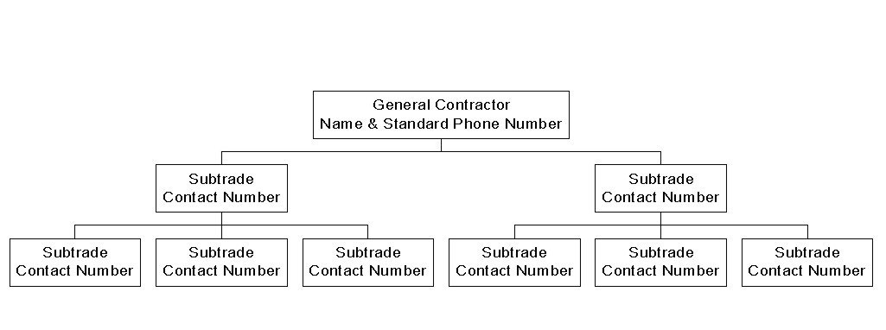
Contact Numbers

Tool Box Meeting Record

Company Name

Date:
Project:
Number in Crew: # Attending:
Trade: Foreman:

Review Last Meeting:

Topics Discussed:

Suggestion Offered:

Action(s) to be Taken:

Injuries/Incidents Reviewed:

Foreman’s Signature:
Supervisor’s Remarks:

Signature: Date:

Note: Record names and signatures of attendees on reverse of page

Posting

Posting will address:

- Relevant Legislation and Regulations

- Committee Members and Contact Information

- Safety Representatives and Contact Information

- Copy of the Nova Scotia Occupational Health and Safety Act

- Department Of Labour and Advanced Education Reporting Number

- Health and Safety Policy as Required

- Compliance Orders or Related Documents

- First Aid Trained Employees and Contact Information

- Location of First Aid Supplies

- Committee Meeting Minutes

- Other Information (as suitable)

Note: Reference Nova Scotia Department of Labour and Advanced Education’s website for any updates to posting requirements.

Emergency Preparedness

This section deals with the various aspects of emergency consideration and will address:

- Identification of probabilities What can go wrong - medical - environmental crisis

- Notification Who do we call or notify - legislative requirements

- Activation Communication & Responsibilities

- Deployment Action Plan

- Operations Specific Responsibilities and Authorities

- Recovery Procedures How do we put the project back up on its’ feet

